Travel and accommodation for POLTEXT Incubator Workshop 2018

The venue: Centre for Social Sciences, Hungarian Academy of Sciences
Address: 4 Tóth Kálmán street, Budapest, Hungary, H-1097
Registration starts at 10am on Thursday, May 10th, on the ground floor.
Transport:
Travel in Budapest: Public transport in Budapest offers an efficient way to get around the city. The network of the Centre for Budapest Transport (BKK) consists of:
- 4 underground lines
- 5 suburban railway lines
- 15 trolley bus lines
- 31 tram lines
- 178 bus routes
Waiting times are acceptable. At peak times, underground trains run every 3 minutes, trolley buses, trams and buses run every 3-5 minutes.
For more information: http://www.bkk.hu/en/main-page/news/
Ticket prices: http://www.bkk.hu/en/tickets-and-passes/prices/

Transport from the Airport Centre for Social Sciences, Hungarian Academy of Sciences (the venue): The city center can be easily reached by taxi, public transportation and of course by car.
- Taxi
Főtaxi, the taxi company with the longest traditions in Hungary will transport passengers between the terminals and Budapest. Főtaxi’s several hundred cars, trained and experienced colleagues ensure a safe basis to satisfy passengers’ needs at a high standard. Taxi drivers speaking at least one foreign language are in service with ‘A’ category big-size cars younger than five years. All cars are equipped with a POS terminal, therefore credit cards are also accepted. Reservations can be made in person at the Főtaxi booths located at the exits at Terminals 2A and 2B. At the taxi rank in front of the stands, taxis are parking continuously waiting for passengers.
- Public transport (by bus, metro, tram)
Passengers are transported by a direct bus service from Terminal 2A and 2B, called the bus 200E, to the Kőbánya-Kispest subway terminal. This service is adjusted to passenger traffic at the airport. Then by M3 metro going to the Nagyvárad square station from Kőbánya-Kispest. In Nagyvárad square with the number 24 tram go 2 stops (Mester street/Heller street) towards Közvágóhíd. Further information: www.bkk.hu
Transport from the Airport to Centre for Social Sciences, Hungarian Academy of Sciences
(details above)

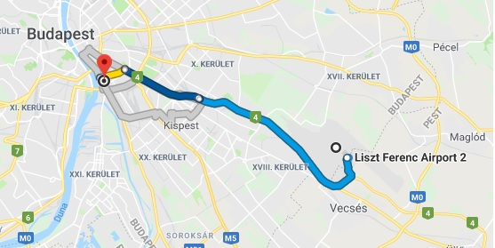

Transport to main hotel (Mercure Buda):
From the Airport goint to Deák Ferenc Square with 100E bus, and transfer the M2 metro towards "Déli" railway station, where the hotel is.

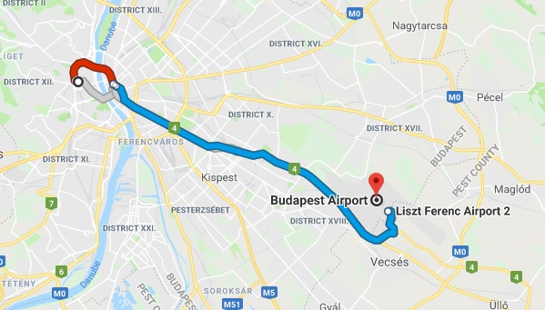

Accommodation
Hotels in Budapest are already close to full capacity for the date of the workshop so we advise you to book your room as soon as possible. We have arranged for a limited number of reduced price rooms (at around EUR 65 based on current conversion rates) at the Mercure Buda. This is a relatively quick ride of around 30-40 minutes from our conference venue. Please reference the coupon code MTA-TK POLTEXT when you contact the sales representative Rita B. KISS at 1688-re@accor.com. We provide further information with regards to travel and accomodation on our website: qta.tk.mta.hu and below.
Other hotel options
Hotel | Rating | Travel time from venue with public transport | Prices /night in EUR
Ibis Hotel | *** | 17 minutes | 75
Hungária City Center | **** | 29 minutes | 50
Danubius Arena Hotel | **** | 31 minutes | 45
Hunguest Hotel Millenium | *** | 18 minutes | 70

